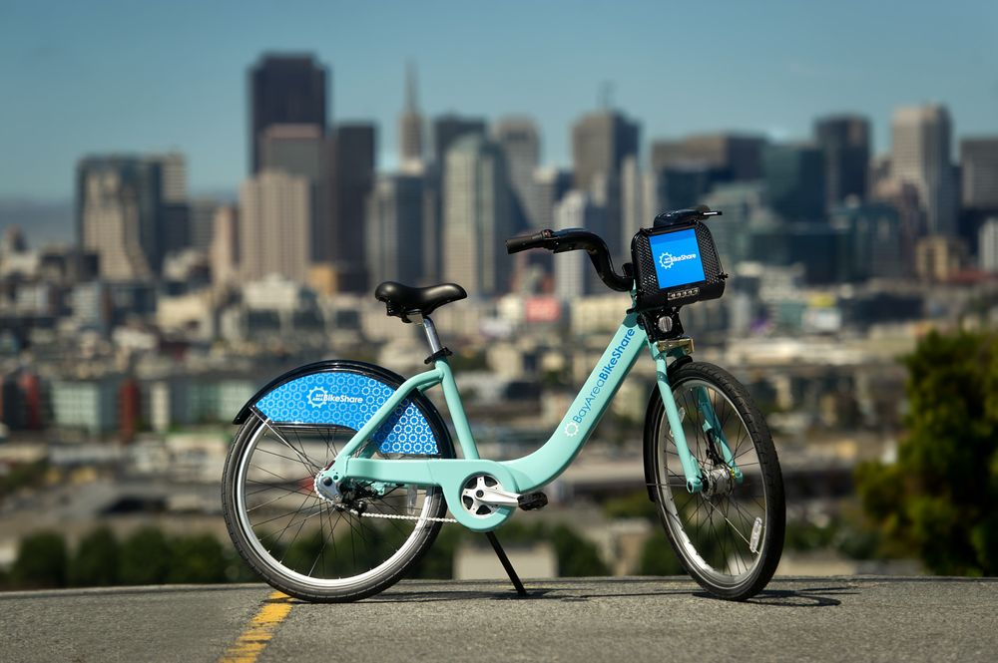

Forecasting Bike Rental Demand in SF

data science capstone project 2

**Rui Cao**

2020-01-30

## Introduction

Bike Sharing System is a modern way to rent bikes and its commonly used in metropolitan cities like San Francisco, New York City, and Washington DC. The process of obtaining membership, renting and returning bikes is automated through networks throughout the city. Using these systems, people can rent a bike from one place and return it to another as needed. Currently, there are more than 500 bike-sharing programs worldwide.

These systems generate a lot of data related to the duration of travel, departure location, arrival location, and time elapsed, which is very useful for study city mobility. Also, understand what factor (like weather, traffic, hourly/daily trend) affects the number of bike rentals will help cities make a better business strategy like how is bikes and docks availability on each station or where future bike stations should be installed.

## Objective

In this project, I will use the SF Bay Area Bike Share dataset <https://www.kaggle.com/benhamner/sf-bay-area-bike-share>

1. Data Wrangling - explore and merge all datasets together, make a new data frame ready to analyze.
2. Data Exploratory Analysis based on a new data frame and see what is the relationship between each factor and the total daily trips.
3. Feature engineering to get the best features which affect the daily trips most.
4. Find the best model to predict daily trips in SF on a selected station.

## Data Wrangling

In this project, I will use 3 datasets: trip, station, and weather. they include a variety of bike-share information between Aug 29,2013, to Aug 30, 2015.

### Trip

the trip dataset has 11 columns and 648717 entries, which describes information about each trip including start/end station id, duration of travel, date of travel, etc.

1. Start by checking the missing values, I found there are 6619 nan values in the zip_code column. because I don’t need this feature for future analysis, I will just leave it like this.

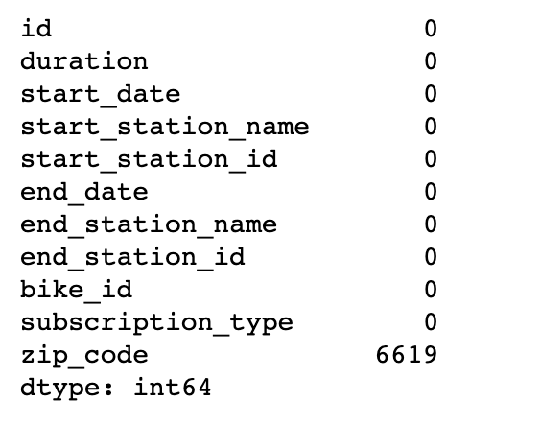

figure1. missing values

1. Check the duration values and remove the outliers by only choose the trip duration of less than 1 hour.

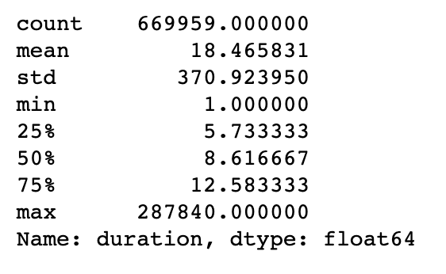 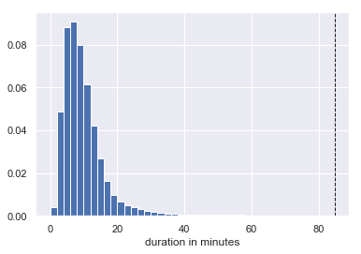

figure 2. duration info

1. Change the date column to DateTime format and use it to add new columns: date, day, hour, month, week. Change the day column pattern from 1-7 to Monday to Friday and month from 1-12 to January to December. Add holiday and working day columns based on the date and day column.
2. Drop not useful columns and change some columns data type from object to category.

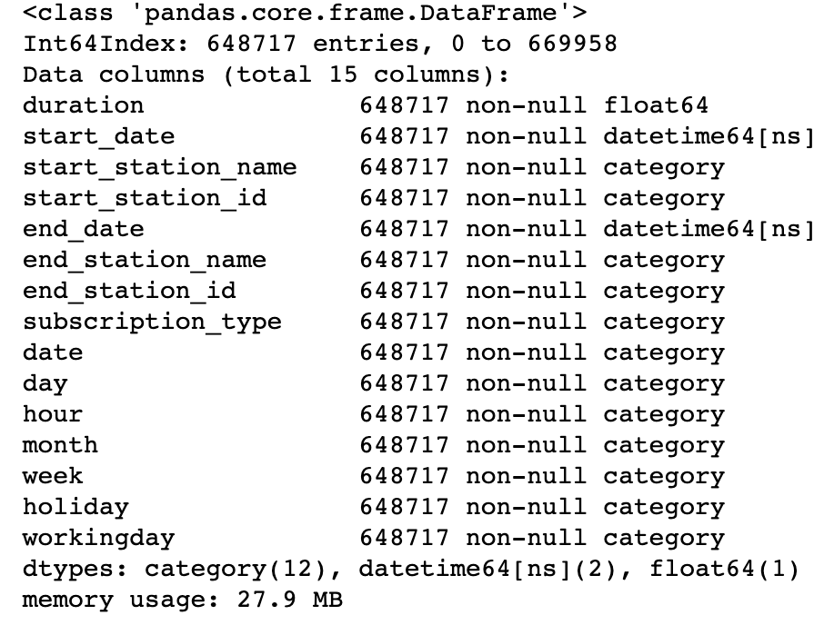

figure3. trip dataset info after wrangling

### Station

the station dataset contains information about 70 stations including name, location, dock_count, city, and installation_date of each station. there are no missing values in this dataset, I just change the columns with ‘object’ data type to ‘category’ and convert installation_data column to data time format.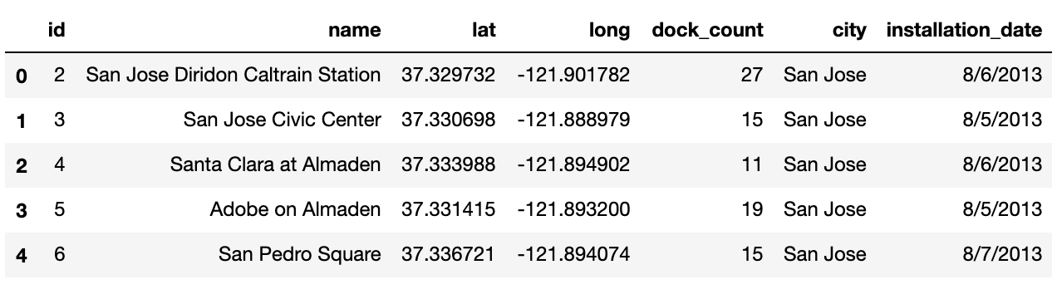

figure 4. station data frame

### Weather

weather dataset includes weather information for 5 major areas: San Francisco, Redwood City, Palo Alto, Mountain View, San Jose. There are almost missing values in every column.

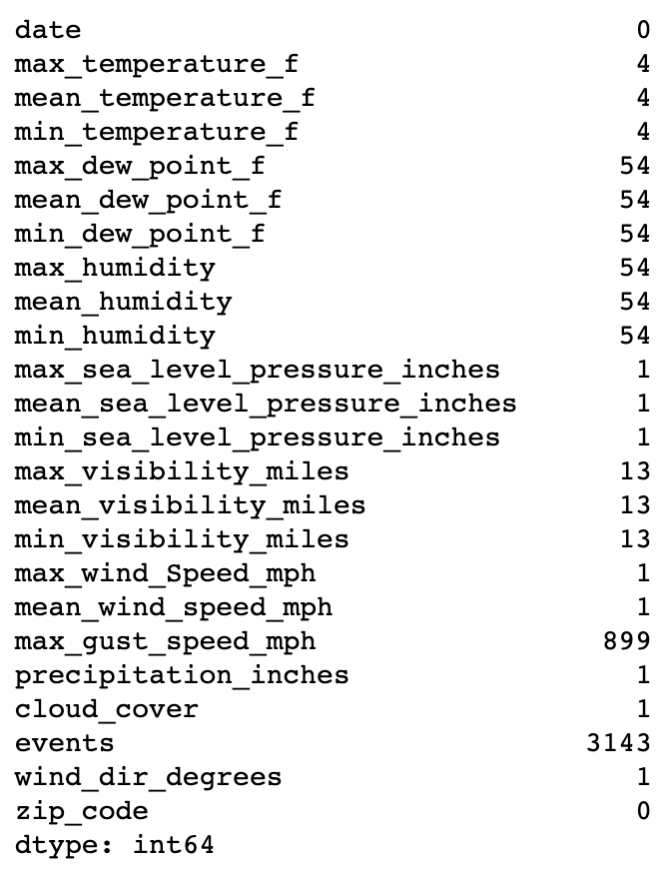

figure 5. missing value in the weather data frame

The events column has the most missing values. It categorizes the weather type in fog, fog-rain, rain, rain- thunderstorms. First, I assume that the NA value represents the normal weather. I fill the nan value with ‘normal’ and then level them up based on wind speed and visibility miles. As the picture shows below, the Normal weather has the highest visibility and acceptable wind speed, I will level it as 0. Ran and Rain_Thunderstorm almost has the same performance. It is so hard to tell which weather will affect the trip counts most: Fog or Rain based on this data. So I would like to temperature level Rain as level 1, Rain-Thunderstorm as level 2, Fog as level 3 and Fog-Rain as level 4 and check the details in EDA. For further machine learning, I will use dummy variables instead of this order for model prediction.

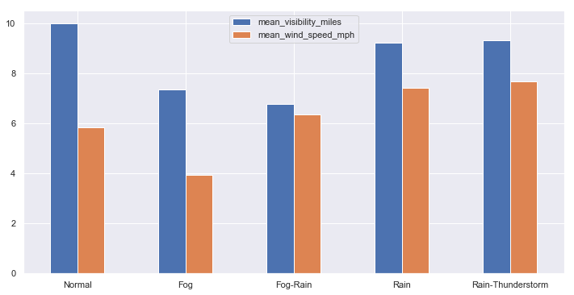

figure 6. weather events on visibility and wind speed

After exploring the dataset make sure there are no unacceptable outliers, I convert objects columns to numeric values and fill nan values with its own average. And finally, map the 4 zip codes with the corresponding city name, change column datatype, adding a new column ‘week’ and drop’zip_code’ column.

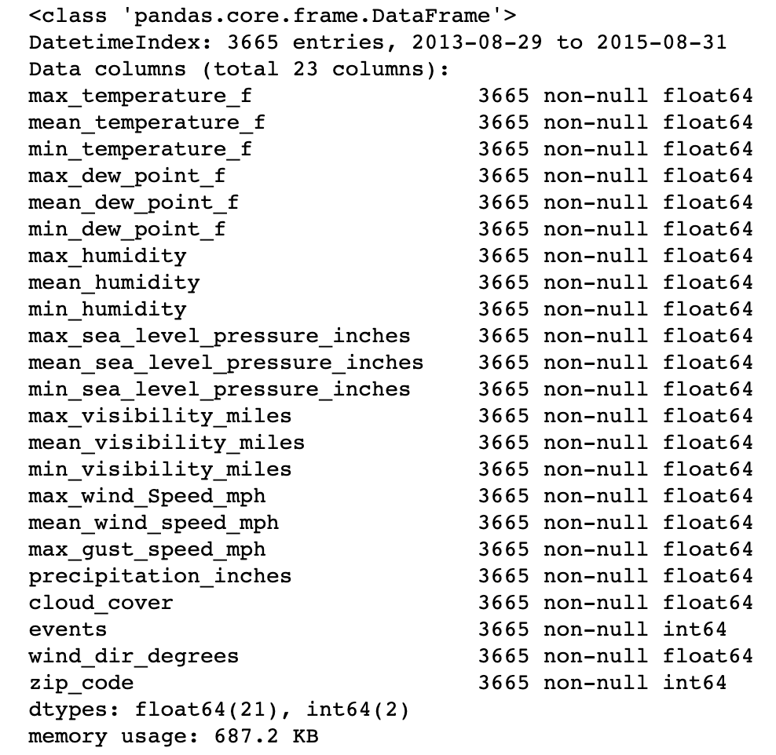

figure 7. weather dataset info after wrangling

### Merging Dataset

I now need to create a data frame for machine learning. from the trip data frame, group by date,station_name, holiday, weekday to get the trip_count on each day by each station, left merge with station data frame on station_name column.

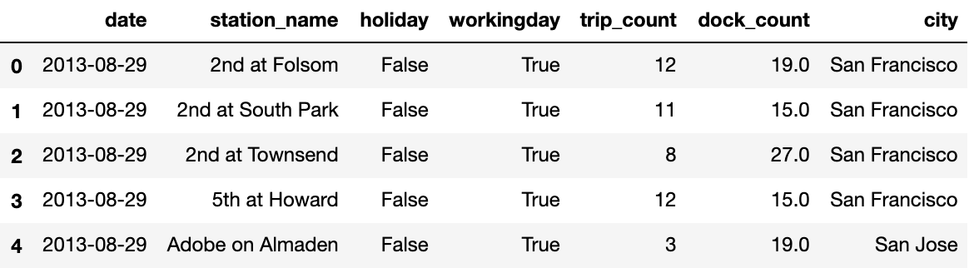

figure 8. merging station and trip data frame

The new data frame has 1150 missing values in the city and dock_count columns, it is because there are 4 stations in the trip dataset not included in the station dataset. Because there is no significant difference in dock_count between each city, I will fill the city column based on the location of station_name and filling the dock_count column with the overall dock mean value.

after fixing the missing value, I will keep merging the data frame with the weather on date and city columns. There are no missing values after merging, just need to change some columns from object to category data type.

Until now, I’ve got 3 well-cleaned data frames and a combined data frame for EDA and Machine learning purposes.

## Exploratory Data Analysis

### Most Commonly used Stations

There is a total of 82 stations listed in this dataset. My main target in this project is to predict the daily trips for an individual station. So the first thing I need to do is to check out which station is the busiest station in SF. I check the top 10 commonly used stations based on the start-station and end-station and find the station named: San Francisco Caltrain(Townsend at 4th) is the most popular station. I will choose this station for my machine learning.

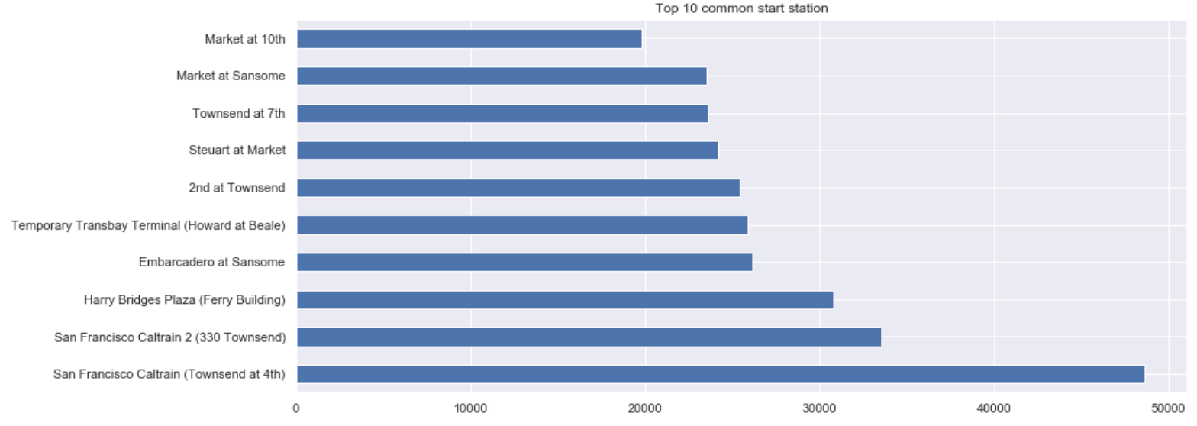

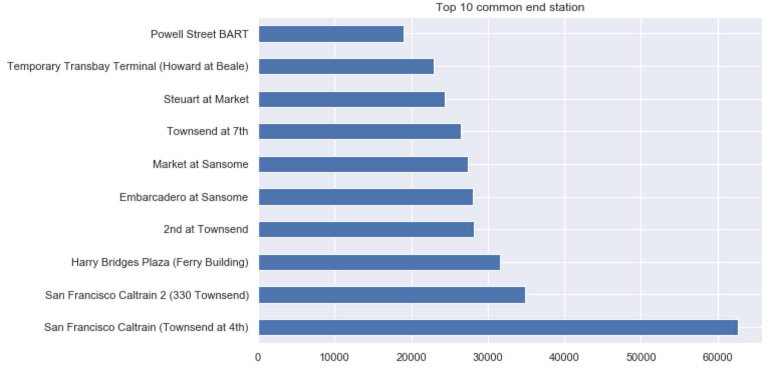

figure 9. most commonly unused station in SF

### Total Trip counts trend by subscription type

To have a deep understanding of who uses this service most, I start by looking into trips by different subscription types: subscriber, the customer(non-subscriber). First, I Check the total trip counts distribution on timestamp by different subscriptions. the people using bike share are most subscribers. The number of daily trips is pretty stable only has a big drop every year around December - January. I assume that most people using this service are for daily transportation, the less usage at the end of the year is due to the holiday season.

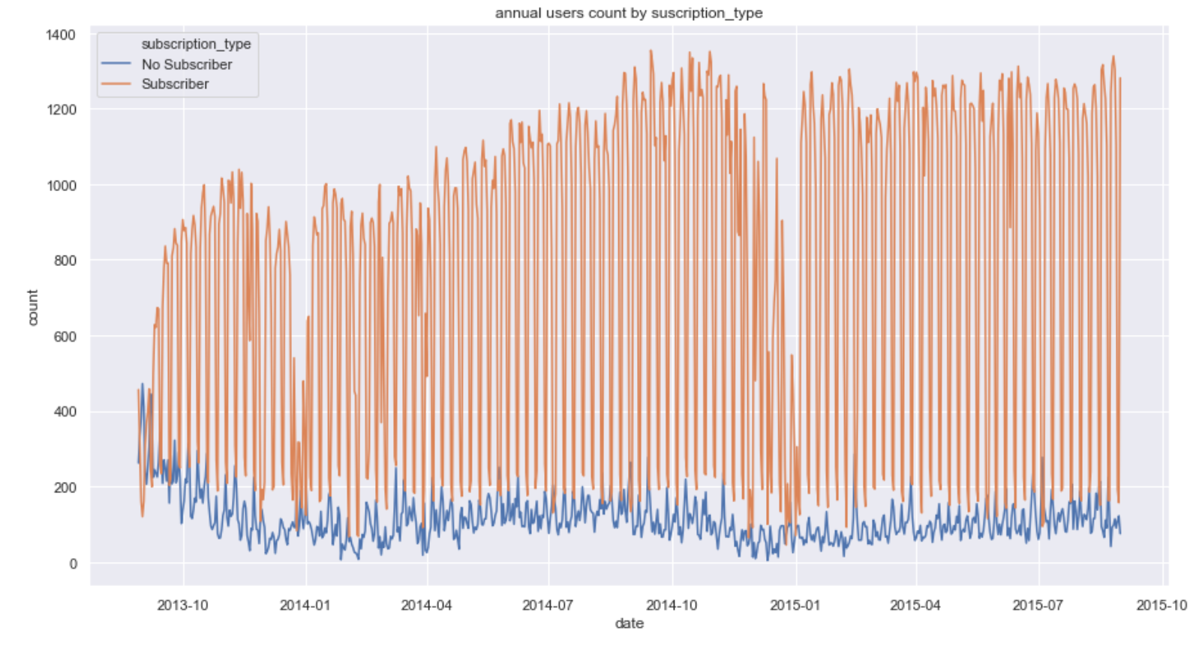

figure 10.overall trips count by subscripthin_type

To confirm my assumption of the main target and how they use the service, I also check the trip counts on weekdays/weekends, holidays by different suscrption_type. As shown in the pictures below, subscribers using the service most times in weekdays and non_hoidays, which approved my assumption.

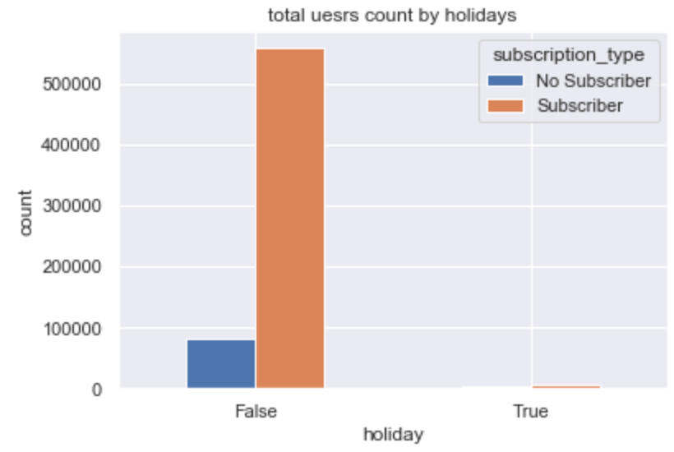 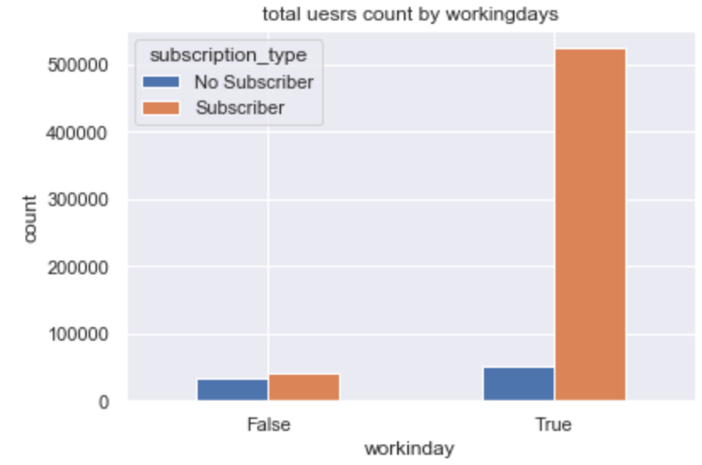

figure 11. trip counts on weekday/holiday by suscription_type

### Trip Counts trend by Month/Day/Hour

Because the weather in SF is very warm，the trip counts by month has no big drop in wintertime. I believe the slight drop in December is due to holiday reasons.

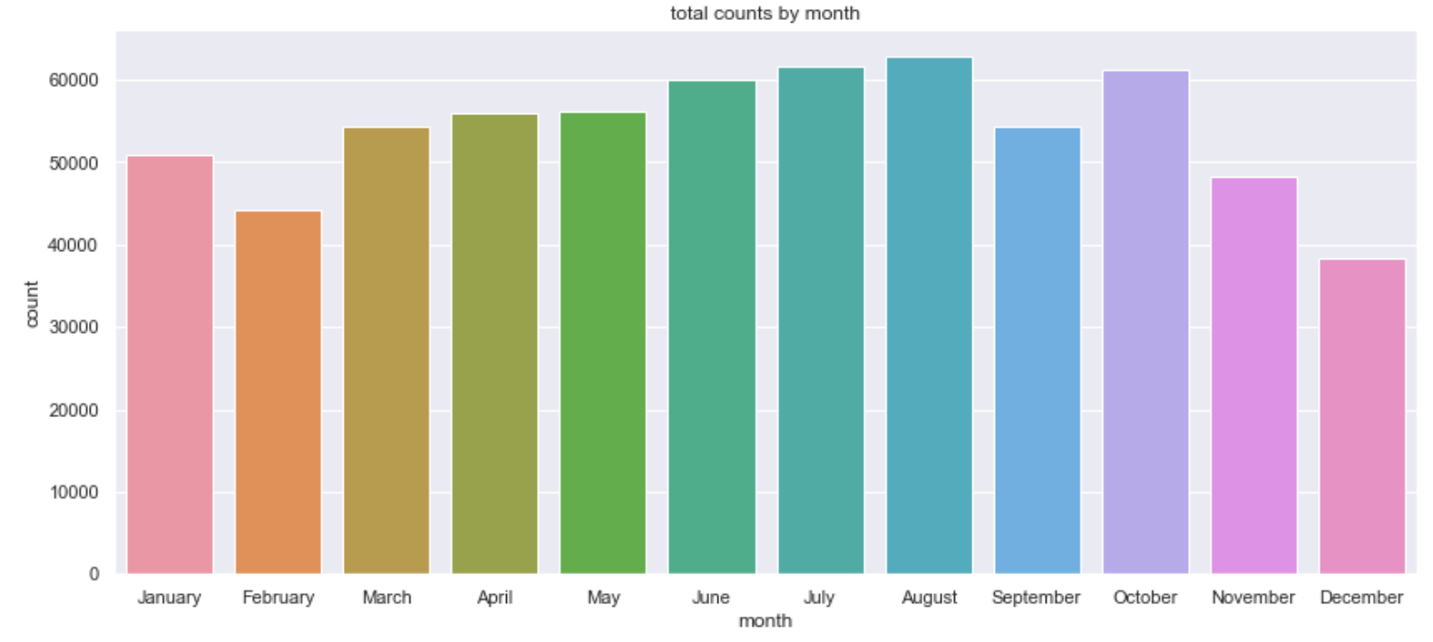

figure 12. trip counts by month

As we already know, customers use the bike-share system most on working days as personal transportation. which hour or which day they use the most? As I deep into the data, I find out that there are no significant different trip counts by non-subscribers. But for subscribers, they usually use the bike on weekdays, especially at peak hours (8 am in the morning and 5 pm at night). I assume that the slight drop on Friday’s peak hours due to some personal choice to work at home on that day.

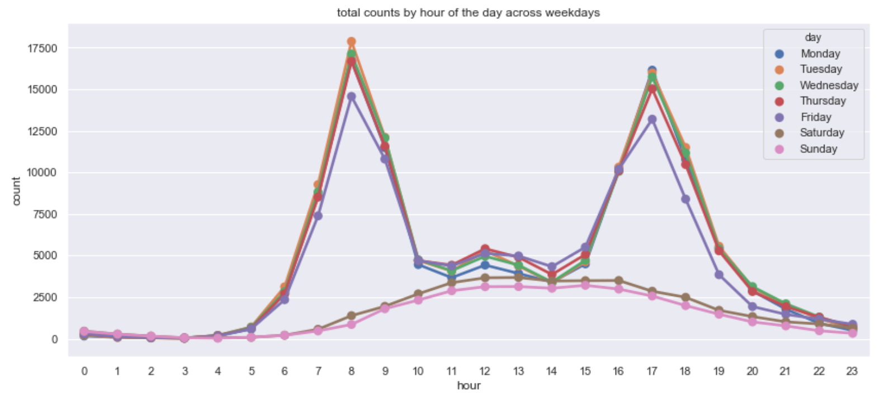

figure 13. trip counts of the day across weekdays

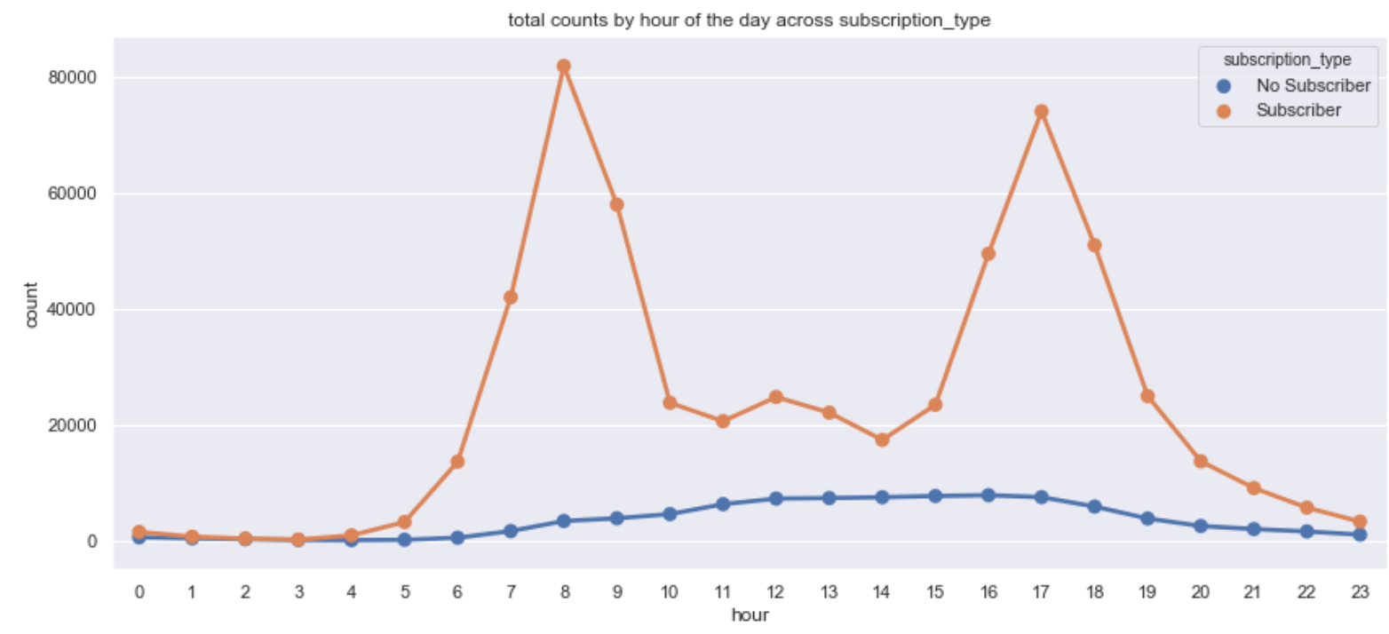

figure 14. trip counts of the day across subscription_type

### Trip counts trend by weather features

There is no clear relationship between each weather features and daily trips. obviously people are willing to use a bike rental service on a normal day rather than fog or raining day. The trip counts have no significant difference between fog and rain but we can see there is more fog weather in wintertime them summer.

Higher the temperature, the more people choose to bike to work. when the wind speed increases more than 10 mph, the trip count starts to reduce. And visibility seems not a key feature for trip counts.

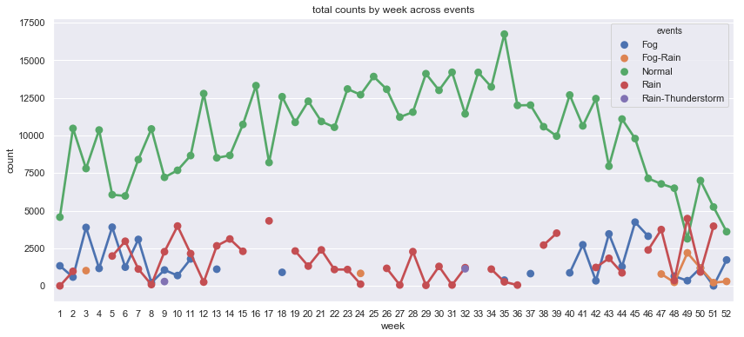

figure 15. trip counts trend by week across events

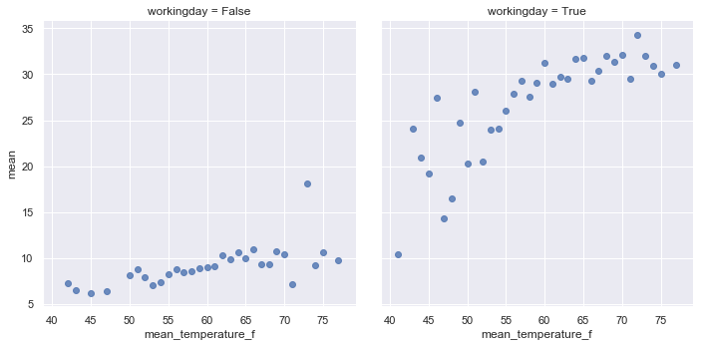 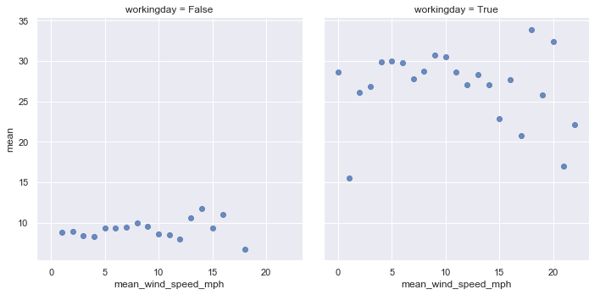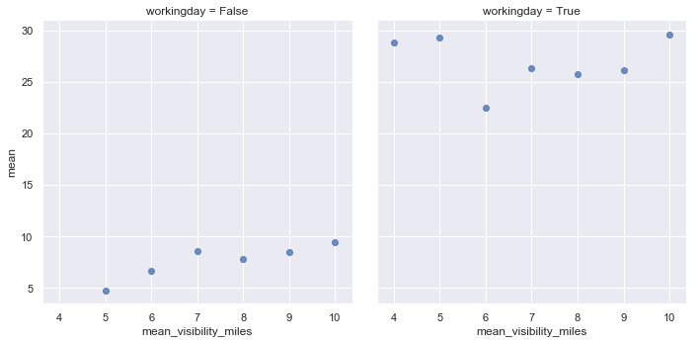

figure 16. trip counts mean vs. temperature,wind_speed, and visibility

## Machine Learning

### Trip Counts Predictive Model

In this project, I aim to build a regression model to predict daily trips on a target station based on the weather, dock_count, week, holiday and working day. I choose the most popular station: San Francisco Caltrain (Townsend at 4th) as my target station. Then get the dummy variables on the events column, finally, because I already choose the particular station and get all the time-series data from the date column, I will

drop the city, station name and date column and set the train, test split ready for modeling.

I try to find the best performance model by checking the mean absolute error on 5 different algorithms: Random Forest, Decision Tree, Linear Regression, Gradient Boosting, and Adaboost. After finding the best parameter using Gridsearch, I decide to use a random forest regressor which has the smallest mean absolute error of 11.69.

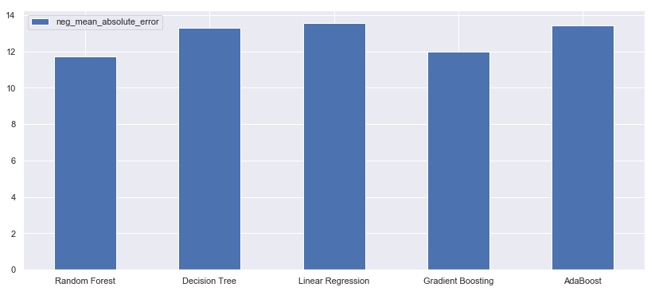

figure 17. mean_absolute_error on different predictive models

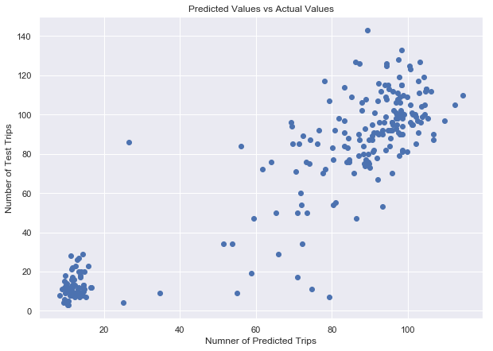

figure 18. predicted value vs. actual value of daily trips

### Feature Engineering

It does not surprise me that the working day has a significant impact on daily trips based on my Exploratory data analysis. Holidays, week of the yeat also are some key features to predict daily trips then weather.

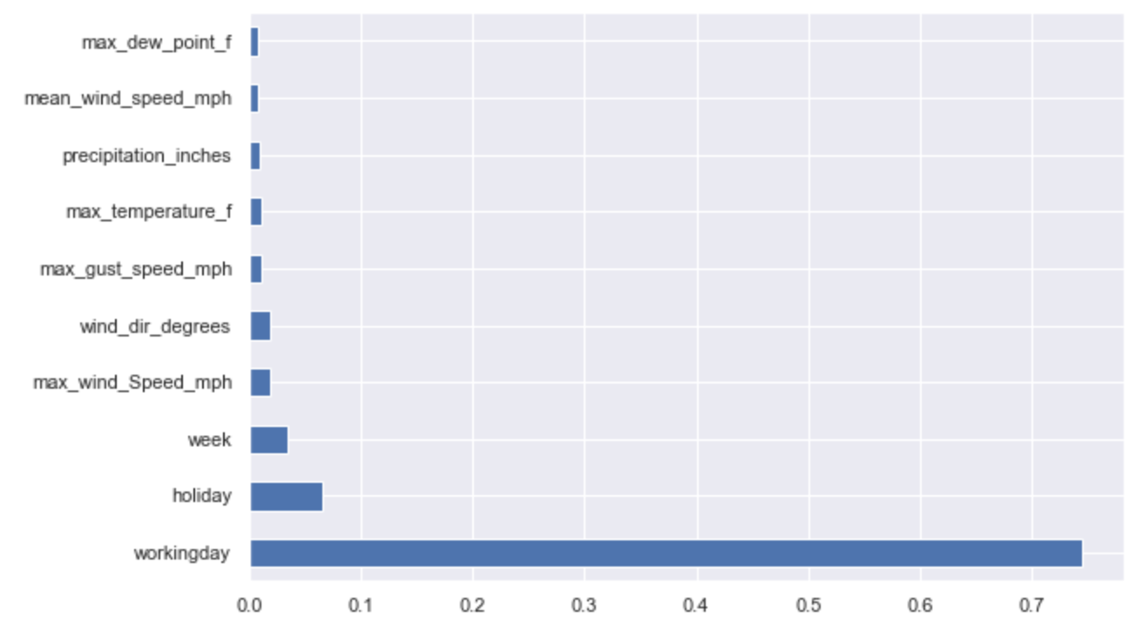

figure 19. Importance Features

## Conclusion

I believe I have made a good model to predict daily trips that will take with the bike-sharing service at a particular station. The mean absolute error of my model is about 11 times a day.

The company could use my model to predict any station usage they are looking for and get a good rough estimate of the dock account they should keep for each day.

To make the model more accurate and usable, The next step I will focus on the larger number of trips, especially between 60-80 trips per day, try to figure out what features affect the numbers and how to optimize the model to make better predictions on those particular days.